Read Me

Question 1 : Newtons' Equation TwoExams

<https://www.kaggle.com/muditr97/assignment-4-newtons-equation-twoexams?scriptVersionId=11612901>

Question 2 : Newtons' Equation MicroChip

<https://www.kaggle.com/muditr97/assignment-4-newtons-equation-microchip?scriptVersionId=11613225>

Data Set:   
 1. TwoExams

2. MicroChip

The Assignment is on Jupyter Notebook  
FileName for Newtons' Equation TwoExams **:**

**ICM2015502__Assignment_4_NewtonEquationTwoExams**

FileName for Gradient Descent MicroChip : **ICM2015502__Assignment_4_NewtonEquationMicroChip**

Open the file which ( is public ) add this to jupyter Notebook, Data set Name : “TwoExams “ and run the code, for question 1.

Open the file which ( is public ) add this to jupyter Notebook, Data set Name : “MicroChip “ and run the code, for question 2.   
It will produce the squared error value for Gradient Descent Algorithm for TwoExams and MicroChip data sets.

Libraries used :

1. NumPy
2. SciPy
3. Pandas
4. Os
5. Sklearn
6. matplotlib

Analysis for Assignment for Logistic Regression

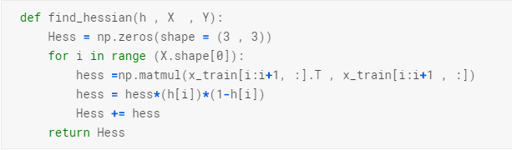

This Program is used to find the Hessian Matrix for newton’s Equation.  
  
   
This is the accuracy of the Newton’s equation for the Two Exams data set.  
  
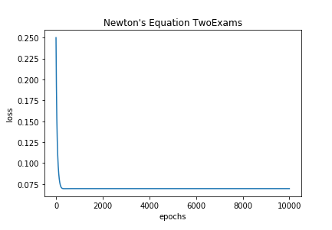

Graph that show the relationship for Loss and Epochs for the Newton’s Equation for TwoExams data set



This is the accuracy of the Newton’s equation for the MicroChip data set.

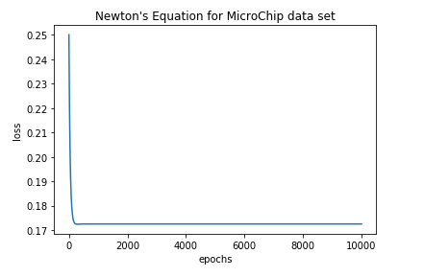

Graph that show the relationship for Loss and Epochs for the Newton’s Equation for MicroChip data set